1. I have downloaded binaries from <http://build.project-osrm.org/> ;
2. Download latest version from https://phabi.ch/2020/05/06/run-osrm-in-docker-on-windows/
3. I have put OpenStreetMap data for my region into the extracted osrm directory ;
4. In the command prompt :  
   a. cd C:\Users\Kévin\Desktop\OSRM\osrm_Release  
   b. osrm-extract –p car.lua pakistan-latest.osm.pbf  
   c. osrm-partition pakistan-latest.osm  
   d. osrm-customize pakistan-latest.osm  
   e. osrm-routed --algorithm=MLD pakistan-latest.osm

<http://127.0.0.1:5000/route/v1/driving/67.112457,24.882638;67.113009,24.882293?overview=false&continue_straight=false>

http://router.project-osrm.org//table/v1/driving/67.112457,24.882638;67.113009,24.882293;67.111032,24.881284?sources=0&destinations=1;2&annotations=distance

<http://router.project-osrm.org/table/v1/driving/67.112457,24.882638;67.113009,24.882293;67.111032,24.881284?annotations=distance>

http://localhost:5000/table/v1/driving/67.112457,24.882638;67.113009,24.882293;67.111032,24.881284?annotations=distance

<https://github.com/Project-OSRM/osrm-backend/issues/5517>

npm osrm

------------------------------------------------------------------------------------------------------------------------------------------

Install latest version of OSRM

<https://phabi.ch/2020/05/06/run-osrm-in-docker-on-windows/>

Download and install Docker

<https://hub.docker.com/editions/community/docker-ce-desktop-windows>

Now, open the Windows shell (hit Windows-key, type ‘cmd’ and hit ENTER) issue the following command in order to get your desired docker image of the osrm backend:

C:\>docker pull osrm/osrm-backend:latest

C:\>docker images

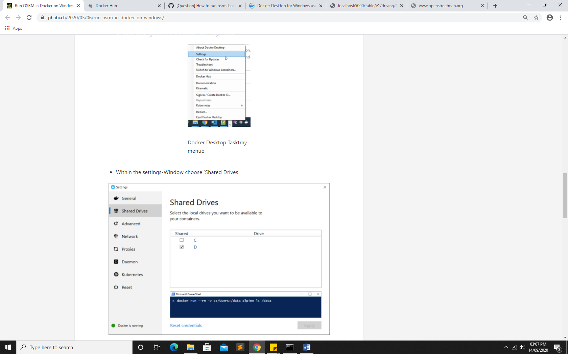

C:\>docker run -t -v d:/data:/data osrm/osrm-backend osrm-extract -p /opt/car.lua /data/pakistan-latest.osm.pbf

C:\>docker run -t -v d:/data:/data osrm/osrm-backend osrm-contract /data/pakistan-latest.osrm

C:\>docker run -t -i -p 5000:5000 -v d:/pakistan:/pakistan osrm/osrm-backend osrm-routed /pakistan/pakistan-latest.osrm

http://localhost:5000/table/v1/driving/67.112457,24.882638;67.113009,24.882293;67.111032,24.881284?annotations=distance

curl <http://127.0.0.1:5000/route/v1/driving/67.112457,24.882638;67.113009,24.882293;67.111032,24.881284?steps=true>

http://localhost:5000/table/v1/driving/46.680113,24.715553;46.729818,24.783569;46.659321,24.750178

?annotations=distance

46.680113,24.715553, 46.729818,24.783569,46.659321,24.750178

90.397802,23.716583; 90.409559, 23.731665; 90.390538, 23.750922

http://evrimo.com/bangladesh/table/v1/driving/90.397802,23.716583; 90.409559, 23.731665; 90.390538, 23.750922

https://www.google.com/maps/dir/ 24.835075,67.032908/24.9074117,67.0589317/24.9091131,67.0590947/24.919025,67.068905/24.91882,67.0808633/24.9137204,67.0811815/24.90518,67.0554513/24.9179168,67.0906968/24.919035,67.0831717/24.8985194,67.0491912/24.9192183,67.0608267/24.9114184,67.0548691/24.9065008,67.0691865/24.9068339,67.0512042/24.9208081,67.0582779/24.9152982,67.0602635/24.91883,67.0688367/24.8980867,67.0469417/24.9138869,67.0802496/24.9326971,67.0944256/24.9014317,67.0546867/24.9425141,67.0860054/24.905285,67.05377667/24.9326746,67.0944313/24.9188392,67.0610258/24.9350915,67.0776712/24.9085785,67.0830245/24.9306215,67.0778531/24.9027888,67.058057/24.932731,67.0948447/24.9361802,67.0780926/24.9313057,67.078743/24.9107496,67.0755969/24.9098422,67.0720605/24.9306789,67.1046553/24.892145,67.046655/24.9216717,67.0893317/24.9340054,67.0849323/24.9326957,67.0943448/24.9152651,67.0600947/24.9433442,67.0947332/24.9281612,67.0906928/24.9092828,67.0706827/24.9124313,67.0795821/24.9038325,67.073454/24.9265717,67.0783817/24.926954,67.0885139/24.927768,67.0742309/24.9339495,67.0936597/24.9070715,67.0613737/

data=!4m37!4m36!1m5!1m1!1s0x3eb338fb580616f9:0x2b24d49dab0f8788!2m2!1d67.1306545!2d24.9164044!1m5!1m1!1s0x3eb338fd906ea265:0xcaebba84790a7239!2m2!1d67.1349914!2d24.9105847!1m0!1m0!1m0!1m0!1m0!1m0!1m0!1m0!1m0!1m0!1m0!1m0!1m0!1m0!1m0!1m0!1m0!1m0!1m0!1m0!1m0!1m0!1m0!3e0